SOME THOUGHTS ON POLLINATION
(Kath Holtzapffel)

I’m not aiming to be very scientific today—many of you know a lot more about pollination than I do—but I would like to arouse your interest in this diverting area and encourage research.

Dr Helen Hewson (former Deputy Director of the Centre for Plant Biodiversity Research) pointed out to my group of trainee guides that plants are handicapped because they cannot move. This means that to reproduce sexually, plants have had to develop ingenious ways to ensure pollination. I will concentrate on angiosperms, that is flowering plants, and Australian species.

It has been said that pollen is the vital link between each generation of flowering plants. It can be dispersed by wind, water and by animal pollinators such as insects, bats and birds. Pollen grains vary tremendously in size and shape and are another fascinating area to research.

Wind dispersal occurs between male and female flower bearing plants such as conifers and casuarinas, and is best suited to mono-stands. The flowers of these species tend to be small and dull. The pollen grains are very small, light and smooth and easily borne on the wind. Grasses and pine trees are examples of this group and lead to much hay fever.

Water dispersal occurs in acquatic species and I won’t dwell on this.

I have seen an estimate that 65% of all flowering plants and some seed plants (such as cycads) require insects for pollination. These insects include bees, beetles, flies, wasps, thrips, butterflies and moths. Insects fly, so can visit many plants in a short amount of time. Insect pollination is more reliable than chance dispersal by wind.

Some insects eat pollen and in the process become covered by it. Other insects eat nectar, and when they enter a flower in search of nectar they brush against the anthers (the pollen bearing male part of the flower) and pollen sticks to their bodies. Pollen is transferred to the stigma (female organ of the flower) of the same plant or another plant of the same species when the insect moves to another flower. Nectar feeding ensures that the insect cannot avoid touching the organs associated with pollination.

In a wonderful article in the Jan-Mar 2006 edition of Australian Geographic it was pointed out that Australia is the nectar kingdom of the world. Nowhere on earth are dominant trees over such large areas pollinated by birds. In Europe not one single plant is adapted for pollination by birds. Mammals include gliders, possums, flying foxes, blossom bats, antechinus, phaseogales, dibblers and more.

Birds and flying foxes can visit more plants per day, carrying more pollen and travelling further. In some forests 80% of birds are honeyeaters.

Plants have evolved countless methods of attracting a suitable pollinator. Orchids are often so specialised that if a particular pollinator were to die out the orchid could not be pollinated.

Flowers which attract birds are usually bright coloured, such as red, pinks and yellows. Often they have somewhere suitable for birds to land.

Flowers attracting mammals are usually duller in colour but have a stronger odour. Those attracting butterflies are generally colourful while those designed for moths are paler in colour and strong in odour, especially at night.

Bees are good pollinators and collect pollen and nectar. They are attracted by scent and not by colour. Many Australian species rely on native bees for pollination. Non-native bees sometimes short cut the route to nectar by cutting through the base of a floral tube and do not actually pollinate the flower. Of course pollen collected or eaten does not always match the plants need for pollination.

In the Eremophila species, those with a projecting bottom ‘lip’ have made a landing pad for insects, while those with a more simple tube are bird pollinated.

Cycads from inland Australia use scent to lure thrips for pollination, up to 50 000 on one male cone. The female cone emits its scent when it is ready to receive pollen thus attracting the pollen laden thrips.

Bursaria spinosa has profuse white, scented flowers. It flowers later than many other local species in order to attract many insects and birds for its pollination. Judging by the number of purse-like seedpods, it is usually successful.

You must have noticed the tiny pink flowers of Grevillea leptobotrys outside the VIC. These would have to be insect pollinated as they are far too small for birds to access.

Some plants now appear to be sterile—have you read the story of the Hakea pulvinifera to the left of the VIC entrance? Perhaps the pollinator species has died out?

I now want to tell you some off-beat pollination stories resulting from recent research for bush food plants in the rain forest. There is a small plant called Wilkiea austroqueenslandica near the Davidson’s plums. I found the name intriguing —and thought how difficult it would be to write labels for Growing Friends if we were ever to propagate it. When I looked it up, I found that it bears yellow, hollow flower receptacles that can be mistaken for fruits. Each receptacle contains numerous tiny perfumed flowers and insects, possibly ants, transfer the pollen from male to female plants. Several black shiny egg-shaped fruits develop from each female flower, and perch on the knobby yellow enlarged receptacle. (See photo p.67 Rainforest Plants VI)

Nearby is another small plant Eupomatia bennetii. It too has an interesting pollination story. It is an ancient species and similar fossils from the Cretaceous have been found in America. It has primitive flowers consisting of staminodes instead of petals and flowers for less than one day on the rainforest floor in low intensity light. It needs to be pollinated in that brief time by small weevils. (see photo p.31 Rainforest Plants I)

Finally there is the weird looking Balanophora fungosa which I saw for the first time in North Queensland and which is now growing at the ANBG. It is a flowering plant resembling fungi. In Rainforest Plants the Nicholsons say it is parasitic on a wide variety of other plants, with a warty fist-sized tuber attaching to their roots by means of suckers. Small white male flowers surround the base of the knob, which is a collection of about 1 million minute female flowers. Although the plant has a bitter taste, honeyeaters lick a sticky substance from around the male flowers. Native rats feed on the pollen and numerous insects visit the droplets of sweet fluid exuded at night by the female flowers. (my photo next page)

There are many more stories out there. Have fun!

Bibliography:
Rainforest Plants Vols I, III and VI, Nan & Hugh Nicholson, Terania Rainforest Publishing 2003
Australian Geographic, Jan–Mar 2006
SGAP Journal May 1973
australianmuseum.net.au/Pollination
http://rainforest-australia.com/Pollination_and_flowers.htm Damon Ramsey for ChambersWildlife Rainforest Lodges, Lake Eacham

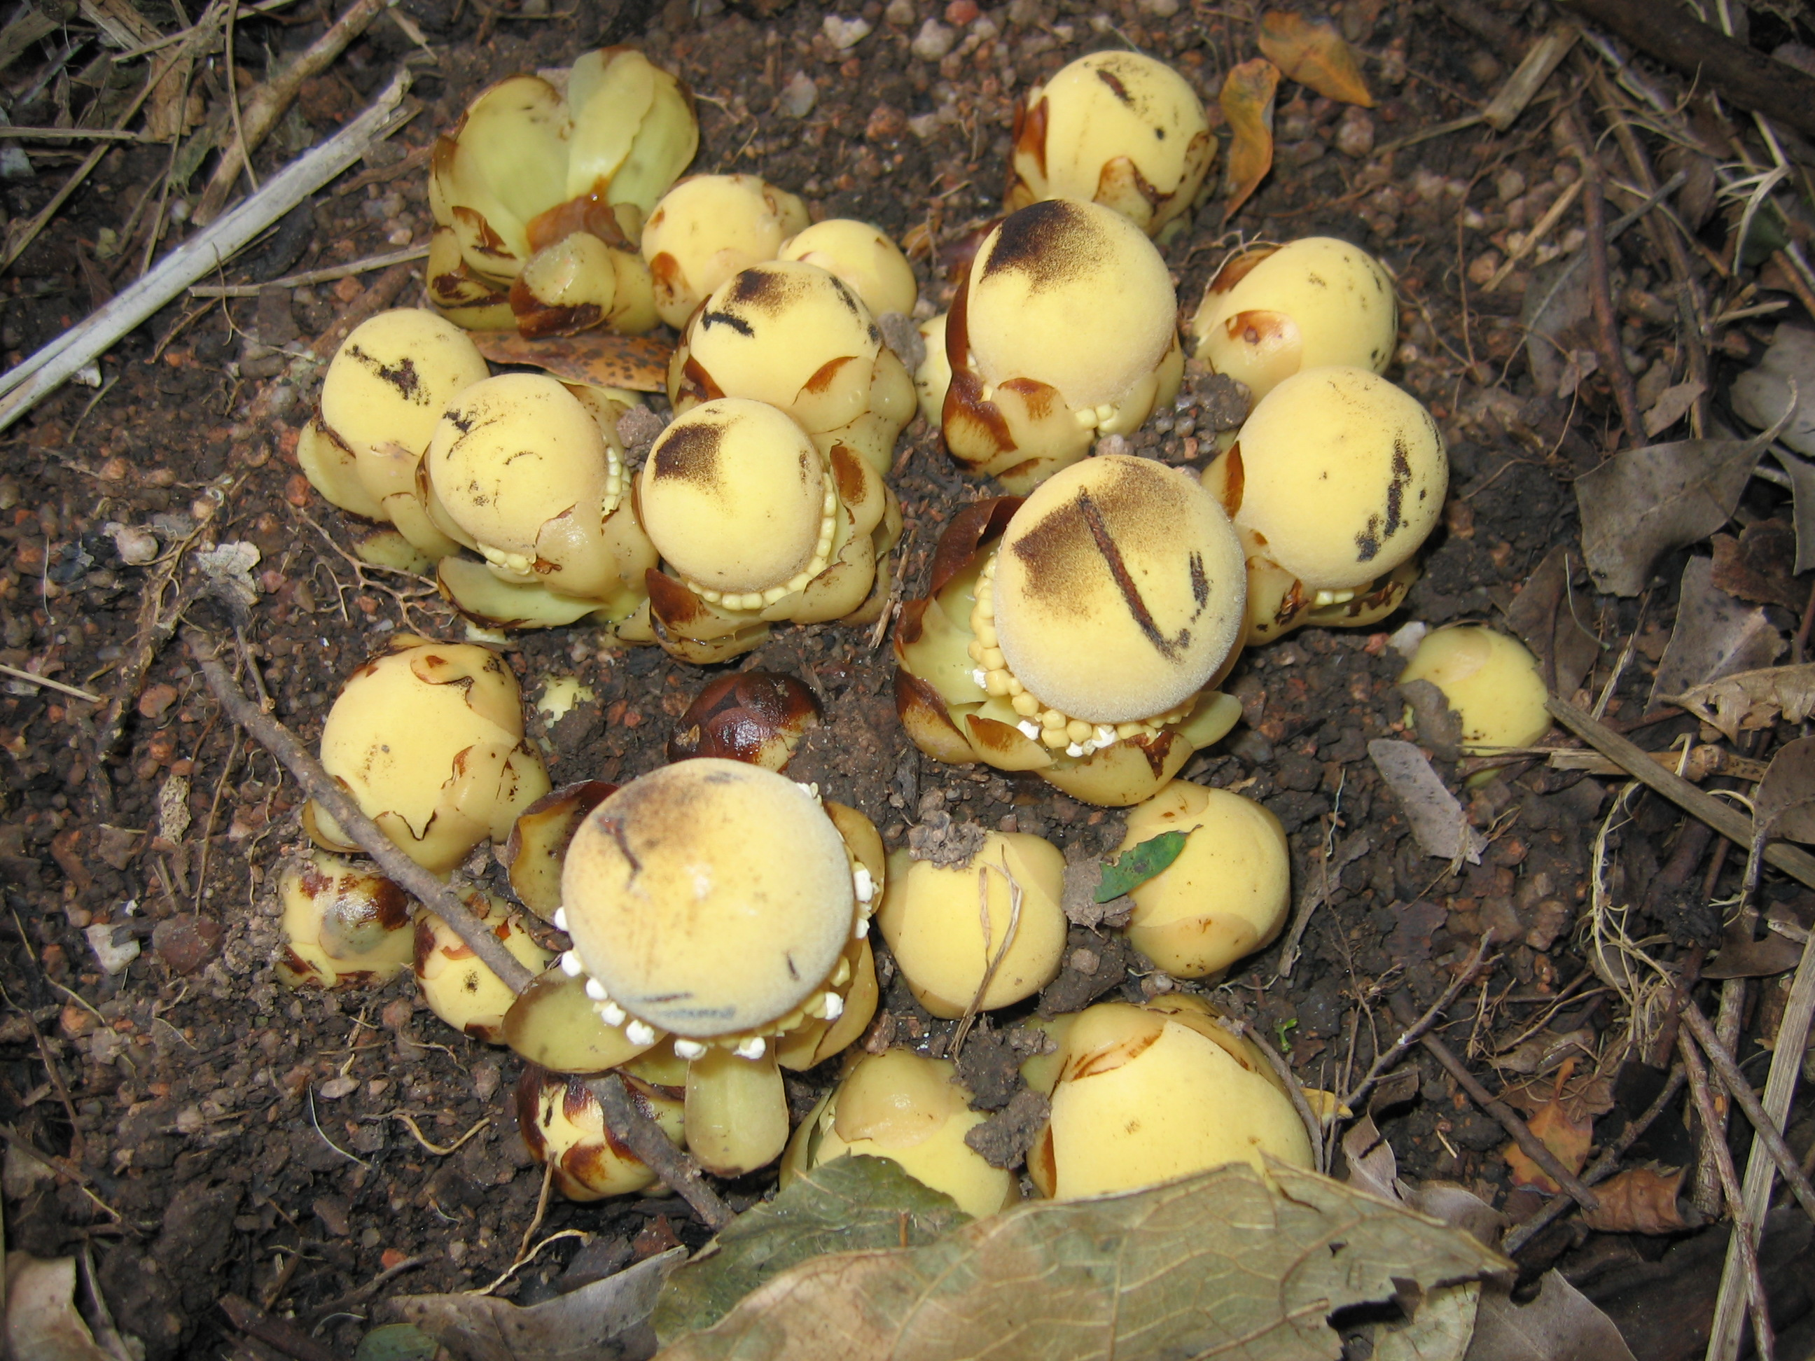
Balanophora fungosa

