​ | 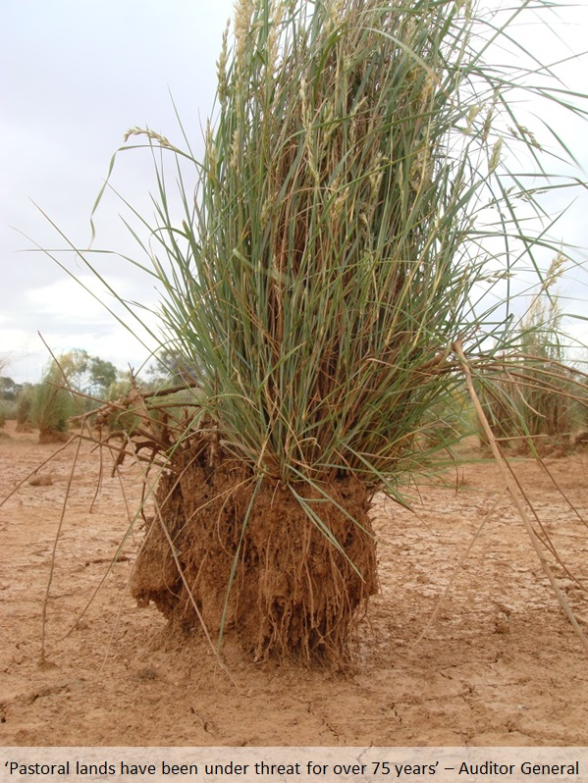  Themeda Trianda - Kangaroo Grass  Despite that sorry news from the Auditor, something fabulous has happened on Wooleen Station. We have discovered something that we have been hoping to see for nearly 30 years. This picture is a species of grass known as Kangaroo grass (Themeda triandra). Early explorers knew the pastoral value of kangaroo grass and recorded it growing profusely in the Murchison catchment, which led to an influx of pastoralists.  Unfortunately, widespread overstocking and the short-lived viability of the kangaroo grass seeds meant that by the time us Pollock’s purchased Wooleen the kangaroo grass was long gone. Not only were the grasses gone, but so were their seeds. There seemed no chance of new plants germinating. In 2012 Frances bought David a 1kg bag of Kangaroo grass seeds for his birthday, which we tried a number of ways to re-establish, including soaking the seed in pools of water in the bottom of this pictured creek. The seed was from Victoria, which meant that it was adapted for vastly different conditions. There was no guarantee that it would grow here at all. Close observation of the different areas where we tried to get the seed established found no plants for years.  Until the 12th October 2017, when we noticed a single plant growing on the bank, a few kilometres downstream of a place we soaked the seeds. After further investigations, we can very excitedly report that there are well over fifty plants growing happily over a 3km section of the creek. This picture is the best patch, which is now stabilising the bank of the creek as it would have done for millennia. This has been David's holy grail of landscape regeneration since taking over Wooleen, and it’s difficult to describe what its presence means.  Essentially, it makes us feel that anything is possible.  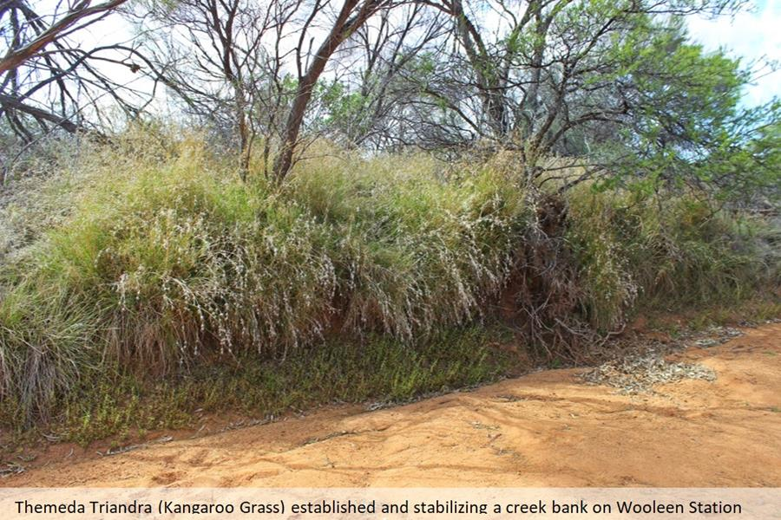  Wajarri Yamatji Native Title  On Thursday the 19th of October Wooleen Station was honoured to host the consent determination of native title for the Wajarri Yamatji people. The legal process for recognising the Wajarri Yamatji people as the traditional owners has been underway for 22 years and the on-country Federal Court hearing finally acknowledged their connection to 68,743 square kilometres of land in Western Australia. Justice John Griffiths flew to Wooleen to preside over the hearing which was attended by over 300 people.  The Wajarri claim is one of the largest in Australia and Australians now formally recognise, under the law, the Wajarri people’s continuous occupation and connection with their land through time immemorial. The determination was by consent of all parties involved including the State of Western Australia, 56 pastoral respondents (including Wooleen Station), some local governments and the Wajarri people. It was not litigation.  Pastoral leases, and the people who currently occupy them, will remain the same as they always have. Despite the 22 year legal ordeal to get to this point, we have always know and believed in the Wajarri connection to country. Many Wajarri lived on Wooleen when the Pollocks bought the pastoral lease, and some of those people remembered Brett Pollock from when he first visited Wooleen in 1954. In the seventies he became a jackaroo and worked alongside many of the people who attended the determination. Consequently we have always operated with an open door policy for Wajarri people to visit, camp and hunt on the property, and we are relieved that Wajarri people have finally been given formal recognition of their rights in this land. The determination outlines the importance for Wajarri people to visit places of cultural or spiritual importance and maintain, care for, and protect those places by carrying out activities to preserve their physical and spiritual integrity.  Now that the Wajarri people’s rights have been formally recognised we will enter into an Indigenous Land Use Agreement (ILUA). This sets out exactly what rights Wajarri people have in the land, and is a negotiation between not only pastoralists and Wajarri people, but all groups with a recognised right in the determined area. We are looking forward to participating in the creation of this agreement, and congratulate the Wajarri people on formally obtaining rights that should never have been denied to them.    

