Developing Public Engagement

Preliminary Report of the ANBG volunteer guides working group
The numbers on rostered walks have been declining since 2013 while the numbers on rostered Flora tours increased steadily to 2016 but have tapered off since then. See Appendix Figure 1. Of particular concern is the number of rostered tours with no takers: 31.3% of rostered walks and 30.8% of Flora tours in 2018. In response to this decline the guides set up a working group (WG) to see if we could enhance visitor satisfaction with the ANBG by increasing public interest and involvement in our guided tours (flora and walks). In particular we sought to identify
- the types of tours that visitors may be interested in, including regular walks, flora and special walks, and the level of that interest
- scheduling and arrangement of tours (timing, starting point, duration)
- how visitors could and do know about tours and potential marketing approaches

The goal of the WG was to identify options and formulate recommendations for the Guides (and potentially Friends and ANBG management) that would better use the services volunteer guides could offer. In particular the WG was interested in recommendations which would increase visitor participation in all types of guided walks.
The WG took an evidence-based approach to the task and this evidence included
- Past statistics on ANBG guided tours, visitor numbers to the gardens and at special events
- Attendance records for a series of specialised walks offered in 2018/2019
- Information on times of attendance at the gardens based on the café bridge and rainforest counters
- Interviews with VIC staff (volunteers and rangers) on visitor inquiries (the VIC survey)
- Collection of data from guides over 3 months as to how visitors knew about the rostered walks and Flora tours. This data was of somewhat limited value as it was collected during the cooler months when visitors’ numbers were low. A second collection has been scheduled for late Spring and early Summer 2019.
- The 2019 ANBG visitor survey
- Examination of tours offered at relevant Australian and overseas gardens, and any information supporting their offerings.
- A google scholar literature search on articles relevant to botanic gardens and visitor expectations
- Review of the Guided Walks Marketing Plan 2014-2016.
- Feedback from guides from other Botanic Gardens at the 2019 Guides conference in Perth

- The types of tours that visitors may be interested in, including regular walks, flora and special walks, and the level of that interest
The literature search identified that the most important reasons given for visiting Botanic Gardens were to enjoy oneself; to admire the garden’s scenery; to spend quality time with family or friends; and to enjoy being outdoors/in nature.
Botanic gardens visitors rated ‘self-restoration’ as more important and ‘learning and discovery’ as less important motivations for visiting. Frequent visitors, in particular, were more likely to be motivated by self-restorative factors. Non-local visitors and first-time visitors, have a higher interest in learning and discovery activities than repeat visitors.
The literature suggests that older visitors are more likely to be motivated by ‘enjoyment of plants/gardens’ than younger visitors and many have an interest in gardening. High attendance levels at the ANBG Thursday talks and the speciality walks confirms that at the ANBG there is still a good level of interest in learning and development for repeat visitors, particularly in this older age group.
Visitor numbers to the gardens peak when family orientated activities are offered e.g. Carramar Koala and Dinosaurs. A well-publicized day of continuous free flora tours was completely booked out when offered on one weekend. Participants included many families.
Other botanic gardens in Australia offer similar general public tours to the ANBG, with some offering specialised walks, often for a fee. Guides from Cranbourne were concerned that their walk fee maybe be contributing to decreasing visitor numbers and they are thinking of removing it. Meanwhile the Melbourne guides have not supported the introduction by the Gardens administration of an $18 fee for bi-weekly regular afternoon walks
No routine family orientated tours are offered by any gardens but it was noted that the Cranbourne BG has initiated a school holiday Kids Explorer bus in July 2019. The bus ran continuously and people could get on and off at various locations. It was free for kids. If children were on the bus the driver adapted the commentary and various ideas had been developed to appeal to them. The initiative has been hugely successful with 1000 passengers during that time, compared to the usual 300.
The ANBG survey identified that 30 % of people would be interested in a guided walk if they returned. The VIC survey found that about 25 % of people were interested in a guided walk when it was suggested, but the level of interest depended on the length of time until the start of the walk and also the weather.
Generally, numbers on rostered tours are lower in May, June, July and August. See Appendix Figure 2. 37% of morning rostered walks and 43% of afternoon rostered walks had no takers during these months in 2018. July is a little different for walks because of school holidays. The numbers of overseas visitors on rostered walks are particularly low in those months also. See Appendix Figure 3. Ideally we should try to attract more local people to our rostered walks in the colder months.
Our analysis of Wattle week suggested that local people are attracted to special themed walks, particularly if they are promoted through local media. Of the 82 who joined a morning walk that week, 62 had come specifically for the wattle walk, while at least six others were very happy to be on a wattle walk. There is potential to offer a special program over these winter months, ideally to coincide with other community events. These would be similar to the way that Eucalypt walks and Wattle walks are currently offered in March and September i.e. they would be rostered walks with a particular theme. For instance, Canberra Tree week is celebrated in early May, NAIDOC week is in July. This plan could be extended to walks in March and October showing some of the plants that are offered for sale at the Autumn and Spring plant sales. However, the months with the smallest number of walks with no takers in 2018 were January, February, March, April and October. There is less need to boost numbers in those months.
In the ANBG 2019 survey, when visitors were asked what the gardens could offer to improve their visit (of the options suggested), the top items were roving guides who can interpret the gardens (30%) followed by 25% who would like activities for families involving plants.
The above finding relates to visitors as a whole, and our research supports there being subgroups with different objectives and that “gardens should consider designing a suite of experiences to cater for different groups”. Based on our research we think there are probably three main subgroups potentially interested in guide enhanced visits i.e.
- Older and repeat visitors (largely over 50). with a high interest in learning and / or gardening.
- Non- local visitors and First-time visitors,
- Families with children under 10
In conclusion, although the majority of visitors to the garden are happiest doing their own thing, there is a substantial number of visitors for whom ANBG visits may be enhanced by taking a guided tour. Tours need to target the appropriate visitor subgroups.

Recommendations
- Continue to offer regular guided walks, with a target audience of non-local and first-time visitors.
- Continue to offer regular specialised booked walks, with a target audience of repeat visitors with a high interest in learning and/or gardening. These walks would continue to dependant on guides interest in offering them and their availability. Some specialised walks can be scheduled to coincide with celebrations and special events in Canberra and at the ANBG
- For 2020 develop a program of themed rostered morning and / or afternoon walks for one week in each of May, June, July and August, ideally to coincide with community events or special ”days” or “weeks” .
Question to guides: Wattle walks and Eucalypt walks have been offered at 11 am in the past but afternoon walks are more likely to have no takers and so would benefit more from having an advertised theme. To avoid confusing the public, should these walks be offered in both morning and afternoon for the whole week? Would some guides be disappointed if they couldn’t provide a rostered walk of their own choosing in these themed weeks?
- Conduct a pilot of a kid’s flora aimed at families with children under 10 during the July school holidays to determine the level of potential demand from this subgroup for guided activities.
- Develop a family guided walk aimed at families with children under 10 and offer it on Sunday afternoons during part of the year
- For 2021, develop a pilot of roving guides in selected areas, (such as the rainforest, red centre garden), with timing and schedule related to the patterns of visitor numbers and events at the garden. This pilot would build on the experiences of the previous program, described in the Appendix, and incorporate an effective mechanism to make visitors aware of these activities. This recommendation is subject to sufficient guides being willing to participate.

- Scheduling and arrangement of tours (timing, starting point, duration)
- Start time
Responses to the VIC survey indicated that time from enquiry to start of walk was a key factor in whether potentially interested visitors went on the walk. In particular if the time to walk start was less than 30 mins, then interest was higher than if it was longer. The general view was that the walk times of 11 and 2 were appropriate but the Flora tour at 10:30 was a bit early and the 1:30 flora impacted on people’s lunch time, so a later time might work better. Some guides mentioned that a 1:30 flora time could be awkward as it excluded them from any family lunch time weekend activities.
Information on visitor attendance time based on counters shows a peak volume on the café bridge at 12-1, and the rainforest at 11-12. The rangers reported anecdotally that the peak time at the VIC is 10:30 to 12:30 and 13:30 – 14:30. This data confirms that offering walks at peak visitor times of 11am and 2pm look like the best times, but the Flora tours should be moved later. Some guides expressed a view that the flora and guided walks should start at different times to avoid congestion at the VIC. However, this may not be an issue if the start location of guided walks changes. The review of Flora Explorer, conducted in 2014, acknowledged the need to separate the starting times of rostered walks and Flora tours.
Recommendation
- Keep the start times of guided walks to 11 am and 2 pm
- Change the start times of Flora tours to 11:30 and 2:30

- Duration
A number of the VIC interviewees said that the reason potential walkers lost interest in a guided walk was that “some members of the party may not be able to cope with a one- hour walk” Although visitors are often told they don’t need to stay for the full hour, it is possible that they are not convinced, or maybe they just think it’s a bit rude to pull out halfway. In a number of cases the visitors have an issue with the parking meter running out during the tour, but there may also be a sub group for whom 1 hour is too long, perhaps more so if they have other commitments or visits to make, or have older companions or children.
No evidence suggested the 45 min duration of Flora tours was inappropriate.
Recommendation
- Keep the duration of guided walks to one hour and Flora trips to 45 mins. Ask all guides to clearly indicate at the start of their tour that they understand some people may need to leave before the end, and they will not be offended if people do so.

- Starting point
Currently tours start at the VIC, which is not the natural entry point for the gardens. Evidence from data collected by guides suggests that 76% of people are not aware of walks or flora tours before they come to the gardens. Hence on-site visible information is important in making people aware of tours. A number of VIC interviewees suggested that having guides visible in place near the café bridge for 15 mins before walks should improve serendipitous uptake of guided walks. VIC interviewees said that having the Flora bus visible near the café bridge before flora tours may attract people to flora tours. However, moving the flora start point away from the VIC would make access to the steps and rugs a problem.

Recommendation
- Move the start point of guided walks to the clock near the café bridge. Ask guides to be in place approx. 15 mins prior to the start
- Retain the start point of Flora Tours at the VIC but continue the practice of parking the bus near the café bridge when practical
- How visitors could and do know about tours and potential marketing approaches

- How people know
As mentioned previously, based on our survey during the colder months, 76 % people are not aware of walks or flora tours before they come to the gardens. It is not clear if this lack of prior knowledge is due to inadequate offsite marketing information or because people are simply not investigating what they want to do at the gardens before they come. Of those 24% that knew about tours before they arrived, 14% knew from the website, 6% from tourist brochures and 4% from social media. There would be value in exploring opportunities to better highlight the availability of tours for first time visitors to the gardens and Canberra, (the target group for rostered walks). Social media does not appear to be an effective way of promoting rostered walks, perhaps because it is used mostly by regular visitors, and tends to focus on special events. It is likely effective in promoting special events e.g. Carramar Koalas, dinosaurs, free flora rides. It may also be useful to promote themed rostered walks suggested in recommendation 3.
Of the 76% of people who hear about the guided tours at the gardens, 50% know from the VIC, or turning up when a walk is about to start, and 16 % becoming aware from seeing on-site signage.
The evidence is that on-site information is important in making people aware of tours as many decide to go on a tour only when they arrive. VIC interviewees said that, due to there being no standard walk, it was harder to promote walks as they couldn’t say beforehand what the walk would cover.
Current signage near the café bridge advertises a range of opportunities with a wide variety of sign type, sign position, colours and styles. For example, on Sunday 25 August there was a confusing array of 8 different signs in this area and it seems unlikely that visitors would have read all of them. VIC interviewees also suggested that there were some pieces of information, such as what times the misters were on, that could enhance visitor experiences. A single highly visible source of information near the café bridge with “what’s on today “was favoured by VIC interviewees.
For specialised walks, advertising through Fronds, ANBG and the Friends’ websites and broadcast emails have been effective in filling walk vacancies. The Cook and the Pacific walks followed a talk by guides at the National Library on the subject, and flyers were distributed. Both the talk and the flyers most likely contributed to the walks’ success. Cross institutional promotion should be undertaken when relevant and possible e.g. Floriade. There may also be an opportunity to have a regular feature in Canberra periodicals, but this would be dependent on sufficient resources.
There was a suggestion of charging for these walks to ensure attendance but it is unlikely that a small charge of, say, $5 would overcome a change of mind. A charge may also give rise to the issue of refunds. More importantly, people who have a genuine reason to cancel need to be able to contact the walk organisers to let them know. Perhaps the phone in the Guides Office could be used for this purpose.
Recommendation
- Establish a working group to work with ANBG management to develop a Marketing Plan for Guided Tours of the Gardens 2020 – 2024 that considers
- opportunities to further promote regular tours through marketing activities targeting visitors to Canberra, including cross institutional/ event marketing and through regular Canberra publications
- a program to market the special themed walk weeks

- Continue the current promotion of specialised booked walks and use cross- institutional promotion when relevant, either at the institution level or between Friends groups. Develop a means of contacting walk organisers for last minute withdrawals.
- Replace much of the disparate signage near the café bridge with a very large single notice board which details all the activities happening that day. It should be
- Highly visible and at eye height
- Updated each day (unless electronic, consider the use of magnetic labels for regular activities)
- Be arranged in timing order
- Contain all visitor activities available that day including walks, flora, misters, exhibitions, talks, café hours
- Consider other on-site opportunities to promote tours such as in the café
- Develop an inspiring script for VIC staff to use to tell visitors about walks that covers what guides are likely to cover but explains about our flexibility. Encourage guides who arrive early to let the VIC staff know what they plan to do on their walk.
- Messaging of marketing material
The objectives of the ANBG focus on scientific collection, research, education, conservation and visitor enjoyment. While these goals are appropriate, apart from the last one, they are not consistent with why people like to come to the gardens. The literature suggests that people come to botanic gardens to enjoy themselves; to admire the garden’s scenery; to spend quality time with family or friends; and to enjoy being outdoors/in nature. Research published in 2008 said that Botanic gardens visitors reported having a relatively low level of interest in and commitment to conservation issues, but this interest may have increased since that time.
However, the lack of interest in education as a reason to visit seems to be more enduring. The 2019 ANBG survey showed that visitors saw education as one of the main roles of the gardens (52 %) along with a peaceful place to relax, (54%) conservation and biodiversity (54%) and a display of plants (51%). However, this learning reason did not translate into why they visited the gardens, which was to view plants’ (67%) followed by walk / exercise (47%) visit cafe (38%) and family outing next (26%).
Despite the emphasis botanic gardens place on educating the public to support their conservation efforts, there is very little research regarding the extent to which visitors are receptive to these messages. The design and delivery of effective conservation learning experiences therefore requires guides to develop a clear idea of visitors’ pre-visit environmental awareness, interest and motivations, and to design messages that enable visitors to make connections between their previous experiences, their immediate surroundings and the issues being interpreted
This research has three main implications for guided tours
- The promotion material of guiding tours should use language that appeals to visitors’ likely motivations e.g. enjoy, interesting, experience, admire, landscape, tranquillity . The current wording on the ANBG website is shown in the Appendix.
- The promotion material for regular guided walks should be targeted at first time visitors to the gardens
- Guides need to be aware of visitors’ visit motivations and be careful how they package conservation and education messages within their tour
Recommendations
- Develop a set of marketing descriptors for guided tours that will appeal to visitors’ likely motivation. Use these descriptors consistently in all distributed written promotional material
Other suggestions
During the course of collecting evidence, a number of other suggestions for change were made that the WG thinks have merit. While they are outside our terms of reference, we have listed them for ANBG management to consider
Flora explorer pricing;
Only pensioners, not seniors, are eligible for concessional fares. This is inconsistent with many other admission charges these days. This creates bad will with seniors and sometimes pensioners don’t have cards on them anyway. People are also looking for a family price. It is recommended
- That the guides recommend to ANBG management that they consider modifying Flora ticket prices so that there is either
- a flat price for everyone with children under 5 free, OR
- a price for adults, a single concessional price including school age children, students, pensioners and seniors, and
- a family price

Appendix

The issues
Figure 1. Annual total visitor numbers on rostered tours
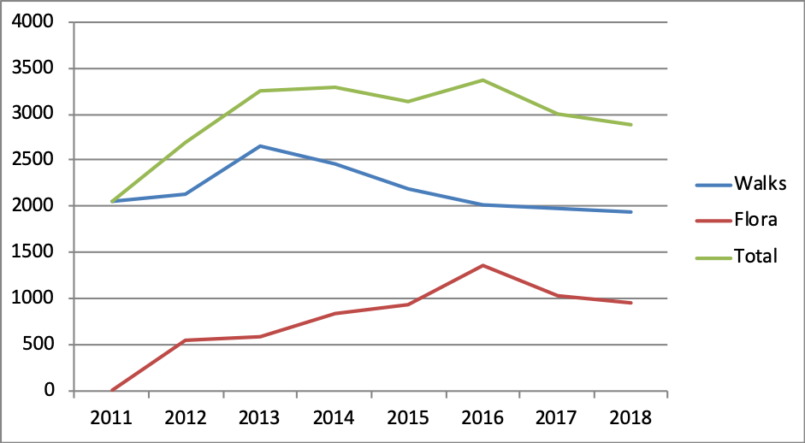
Figure 2. Average numbers of visitors per month on rostered tours. Walks averages refer to years 2005-2018. Flora averages refer to 2015-2018. Flora numbers are lower because they run on weekends and public holidays and occasionally during school holidays.
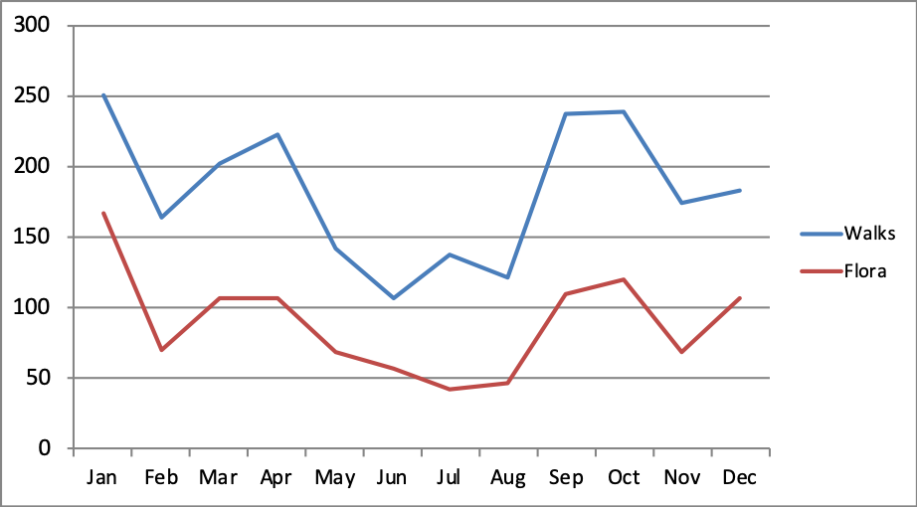
Figure 3. Numbers of Australian and overseas visitors on rostered walks by month in 2016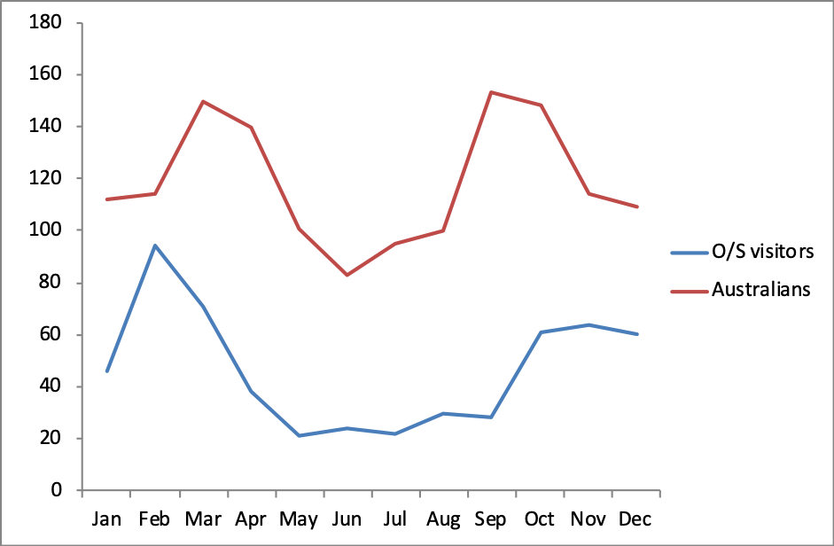

Roving guide program history
A roving guide program was introduced in the Red Centre Garden when it was first opened during the summer of 2013-14. Guides were in attendance for an hour from 9.45 am. In May 2014 it was recognised that neither guides nor visitors were keen to rove in the RCG in the early morning and evening at that time of the year. It was noted that roving RCG guides had made contact with 170 visitors the previous month (April). Weekends were considered to be the most important time to have guides in the RCG, but many guides did not want to be limited to weekends.
It was decided that there would be value in having roving guides in the RCG between 12:30 and 1:30 on any day of the week. In September 2014, there was a discussion about the merits of keeping the Roving guides in the RCG. It was finally agreed to keep the roving guide’s roster during Floriade, and to reassess the issue of the roving guides, at the next guides meeting. In October 2014, a show of hands indicated there was little support for the RCG roving roster and it was abandoned. Guides were encouraged to continue roving in the RCG whenever they wished and to advise the VIC when they would be there. Very few guides pursued this option.

Marketing
Tim Kilby’s approach to marketing the Wattle Week walks was as follows:
First he approached Julie Akmacic to make sure the ANBG were happy with publicising the walks. Julie made the contacts with ABC 666, 2CC Garden Gurus and WIN News. She was happy to do this if Tim would do the talking. She thought only 2CC would respond. In the end Tim did chats on 2XX (1 hour Radio Landcare), 2CC (5 mins Gardening) 666 (15 mins Sunday morning) WIN News 4 pm & Facebook (2mins). Tim noted that these media outlets are unlikely to want him to come for four successive months. So we would need to be selective about frequency and content of this approach.
We can advertise community events in thefollowing:
- 2XX has 'Radio Landcare' with 'Tom and Margaret'. Contact Tom via allbaker@bigpond.com.au for an interview well ahead.
- 2CA - https://www.2ca.com.au website. 'Upcoming Events' invites you to add to the list.
- Mix 106.3 https://www.mix106.com.au website. From home page go to 'Community Switch' and add event.
- To submit events to Events ACT you first must register. See http://events.act.gov.au/
Some stations will read community announcements on air
- Valley FM 89.5 email Tony Briscoe at brisman@bigpond.com with info
- QBN 96.7 email Yvette Latu at yelatu@bigpond.com

Current Wording on ANBG website
Get the most out of your visit to the Gardens on a guided walk.
Led by our knowledgeable guides, these walks allow you to appreciate the beauty and clever adaptations of Australian plants and the research and effort involved in creating and maintaining the gardens.
Every guided walk is different. Guides share stories about the fascinating array of Australian plants on display and the Gardens’ many achievements.

A roving guide program for the RCC was trialled in 2014 with limited success. Further details in Appendix
The July school holidays timing would be subject to checking if this was consistent with other ANBG management initiatives
Note visitors were allowed to nominate multiple roles

