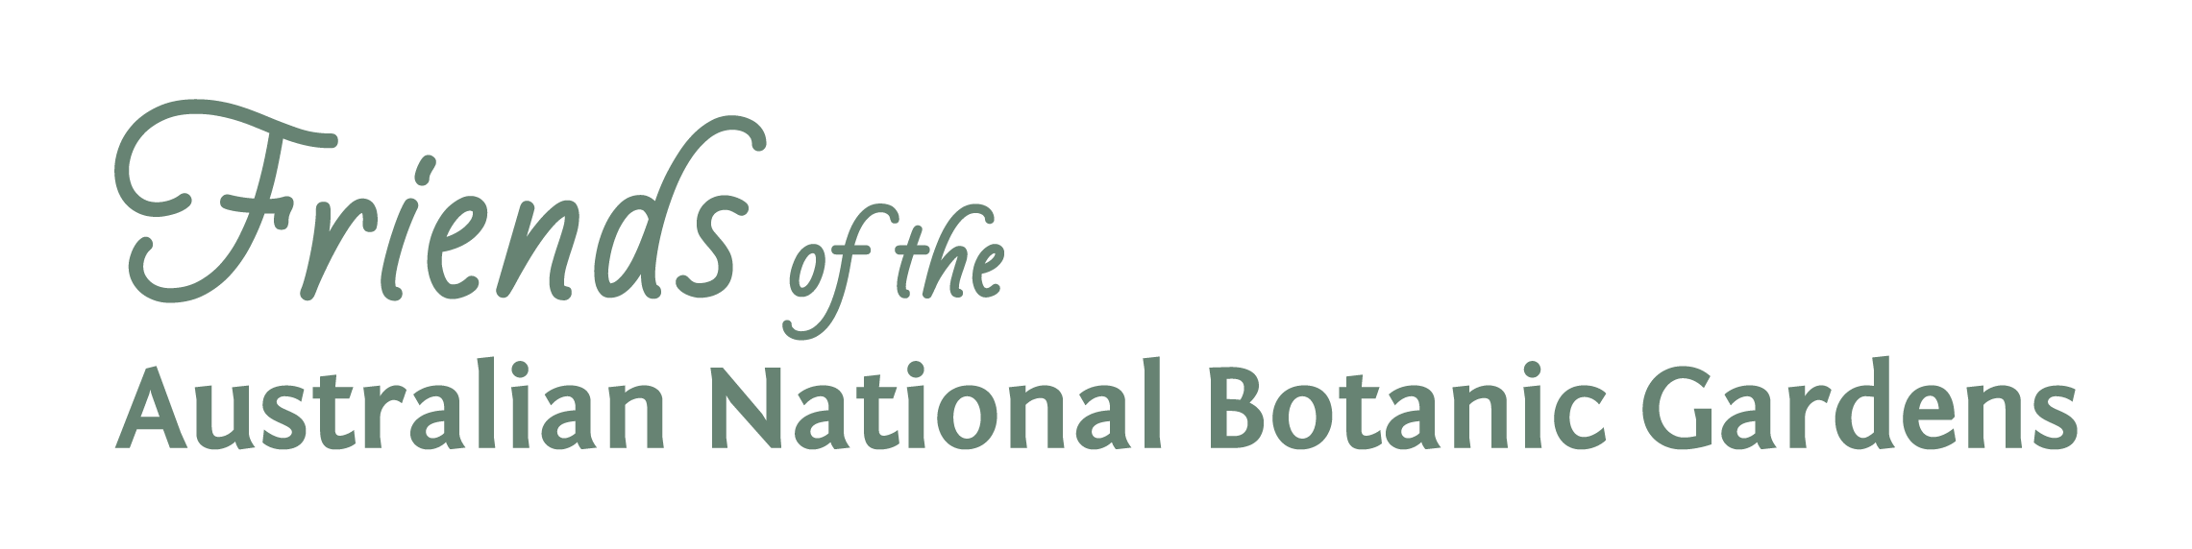
Annual General Meeting, Tuesday 31 October 2017
Nomination for Council

I..................................................................................(name of nominee)

of........................................................................................................................................

................................................................................................................. (address)

Phone number: ..........................

email: ........................................................................

wish to nominate as Vice President, Secretary or Council Member (delete whichever does not apply) of the Friends of the Australian National Botanic Gardens.

At the AGM, elections will be held for the position of Vice-President, Secretary and two (2) Council Members. If a current member of Council nominates for a position other than the one currently held, and is elected, there will be an extra vacancy. Election is for a two year term for all positions on Council. Council members may take responsibility for particular activities, such as membership, projects, social activities, newsletter, volunteer coordination etc.

I agree to promote the aims and objectives of the Friends of the Australian National Botanic Gardens and am a financial member of the Association. I am particularly interested in

Thursday Talks | Social and special events | Membership | Visitor Centre
Newsletter  Photography group | Website  Guides | Growing Friends  Botanic Art | Projects Committee  Plant Science

Other (please specify) ………………………………………..

Signed by Nominee............................................................Membership Number.......................

Proposed by........................................................................(printed name)

………………………………………………(signature)

Membership Number............................

Seconded by.......................................................................(printed name)

………………………………………………(signature)

Membership Number............................

Nominees are asked to provide a written ‘profile’ of 50 to 100 words, saying a little about their relevant background, experience and interests. These will be distributed at the AGM.

The Friends of ANBG are registered with the Australian Charities and Not for Profits Commission (ACNC) and are required to comply with their corporate governance standards. In accordance with these standards I declare that I am not, nor have ever been, disqualified from managing a corporation under the Corporations Act 2001 or disqualified from being a responsible person of a registered charity by the ACNC Commissioner.

Nomination forms and profiles can be lodged with the Secretary, Friends of ANBG Inc, GPO Box 1777, Canberra ACT 2601 or left in the Friends box at the Visitor Information Centre at the Gardens by 24 October 2017

